|  |  |  |
| --- | --- | --- |
|  | **BAHRIA UNIVERSITY, (Karachi Campus)**  *Department of Software Engineering*  **Open Ended Lab -1**  **Semester Fall 2021** |  |

**Course Title:** Computer Architecture and Logic Design **Course Code**: CEL 221

**Course Instructor:** Dr. Samar Yazdani **Class**: BSE-3(B)

**Lab Instructor:** Engr. Ramsha Mashood

**Name: Muhammad Junaid Saleem Qadri E.no: 02-131202-057**

**Max. Marks:** 30 Marks **Reg no: 70003**

**Time:**  1 hours **Date:** 24-11-2021

**NOTE:**

* Plagiarism is not allowed, if found you will get zero marks.
* Try to submit the task on LMS in given Time.
* Include your name or enrollment no on footer.
* Your File name should be in the given format:
  + [Class Section] [Complete Name] CPOEL1 **i.e., BSE3A Usman Ali CALDOEL1**

**TASK # 01:** (**Marks: 20)**

1. Write a program to calculate area of circle given the radius. The radius are read from the standard input after prompting the user and then program computes the area and print it on standard output.

**Solution:**

.data

pi: .word 3

input: .asciiz "Enter the radius : "

result: .asciiz "Area of Circle is = "

.text

la $a0,input

li $v0,4

syscall

li $v0,5

syscall

move $t0,$v0

mult $t0,$t0

mflo $t2

lw $t4,pi

mult $t2,$t4

mflo $t5

move $s0,$t5

la $a0,result

li $v0,4

syscall

move $a0,$s0

li $v0,1

syscall

li $v0,10

syscall

**OUTPUT:**

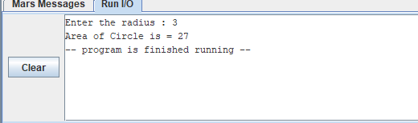

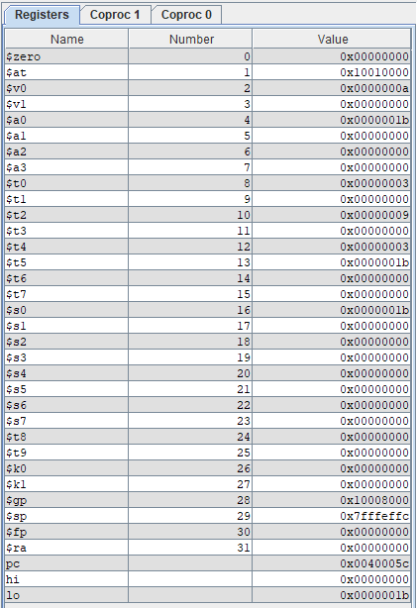

1. Modify the program to make it work on multiple inputs. In particular, it should repeatedly ask for radius values, and print the corresponding area and perimeter, until the user enters the value 0 for radius. At that point, the program should terminate.

**Solution:**

.data

pi: .word 3

input: .asciiz "\nEnter the radius : "

result: .asciiz "Area of Circle is = "

.text

loop:

la $a0,input

li $v0,4

syscall

li $v0,5

syscall

move $t0,$v0

beqz $t0,by

mult $t0,$t0

mflo $t2

lw $t4,pi

mult $t2,$t4

mflo $t5

move $s0,$t5

la $a0,result

li $v0,4

syscall

move $a0,$s0

li $v0,1

syscall

b loop

by:

li $v0,10

syscall

**Ouput:**

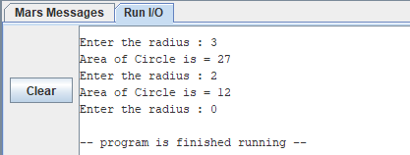

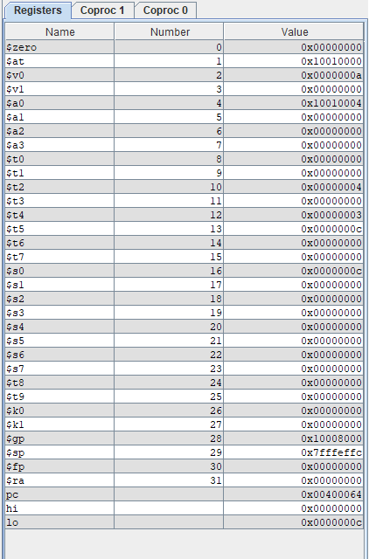

**TASK # 02:** (**Marks: 05)**

For each program, answer the question about the result.

1. What is the value in the given registers when the program completes?

addi $t0, $zero,4 add $t1, $t0, $t0

|  |  |
| --- | --- |
| $t0 | 4 |
| $t1 | 8 |

1. What is the value in the given registers when the program completes?

addi $t0, $zero, 2

|  |  |
| --- | --- |
| $t0 | 2 |
| $t1 | 2 |

addi $t1, $zero, 2

beq $t0, $t1, A

addi $t1, $zero, 1

A: